- Create an EC2 machine and add the script in user data to install docker by default or launch an EC2 machine and use the script to install docker. You can find script in official docker website in documentation.
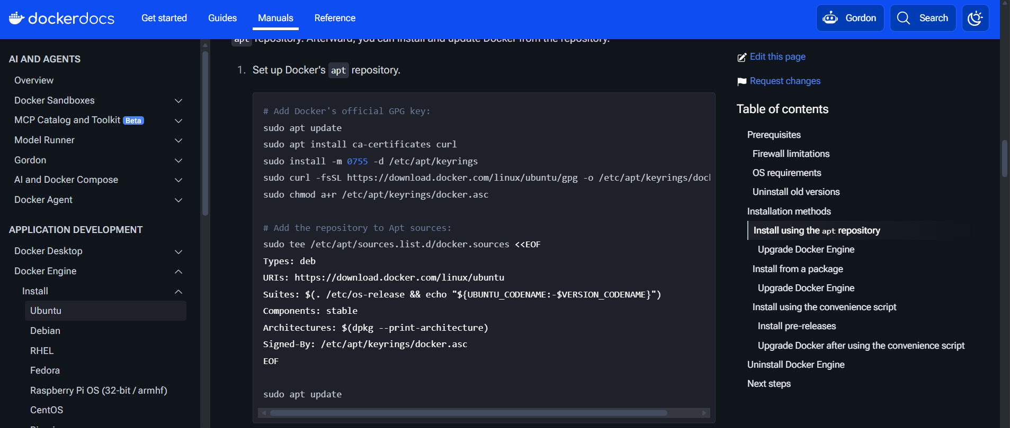

- Check docker service is running or not by entering “systemctl status docker”
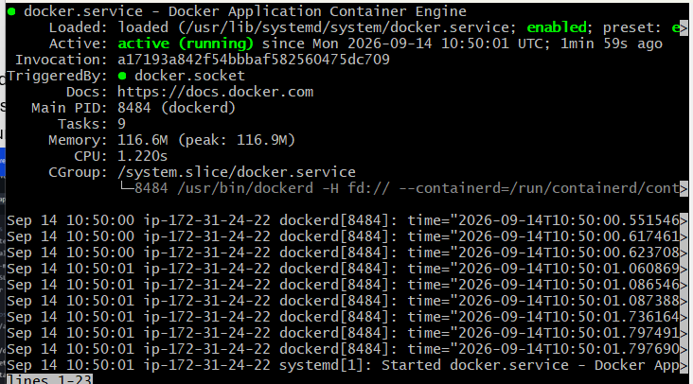
- By default, the user will not have permission to access the docker images only the root user has it, so add the user into docker group
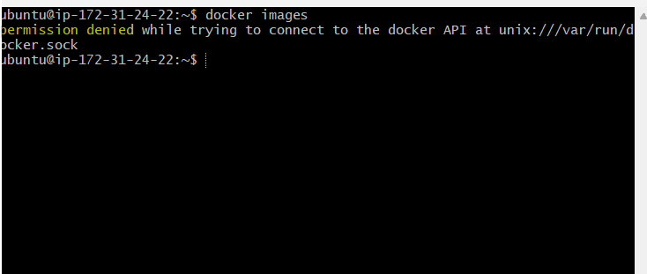
After adding ubuntu in docker group

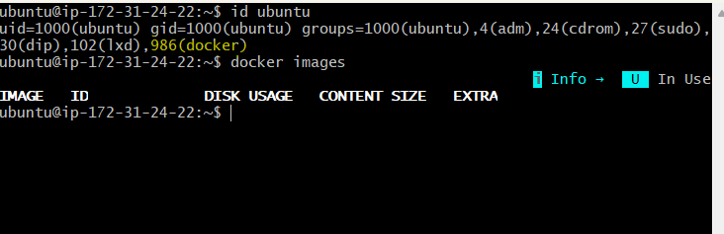
- Create a directory to store the image
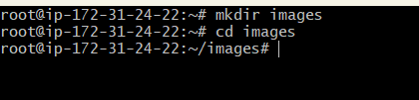
- We can create a website template to host of the container too. I have used toolplate template (https://www.tooplate.com/zip-templates/2168_sweet_bakery.zip)
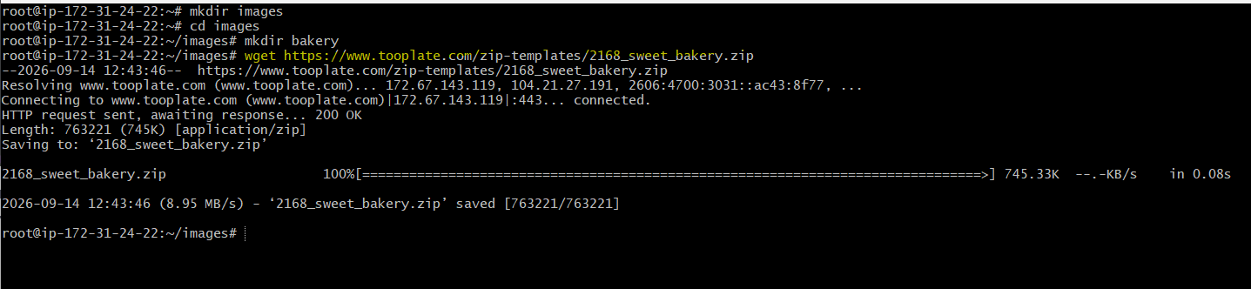
Unzip the file and add in tar format
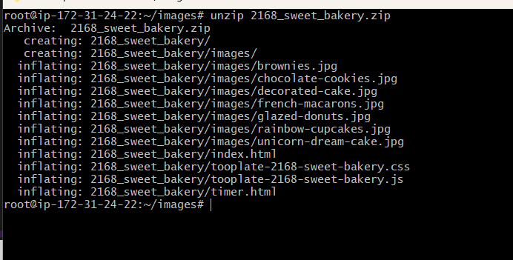

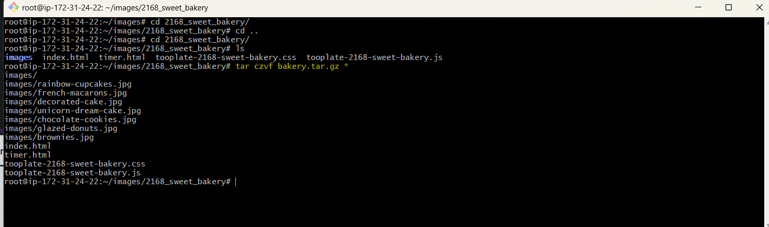
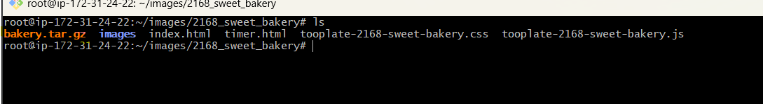
Moving the tar file to the directory created for it
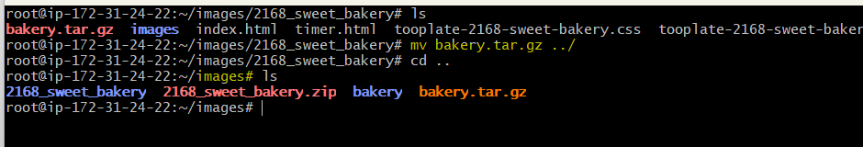
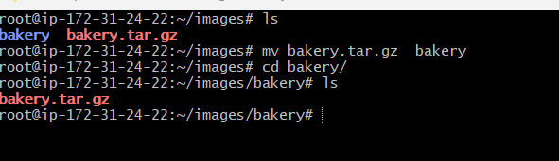
- The website tar file is ready to use, so we can use it in docker container.
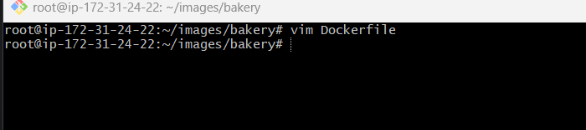
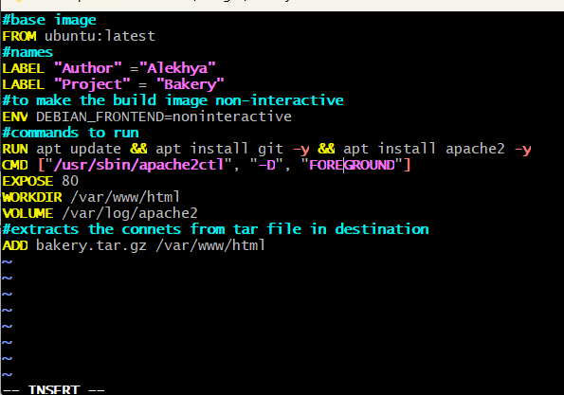
Building docker image (. Is used to show the directory we can give directory name also since the image is the pwd I used .)
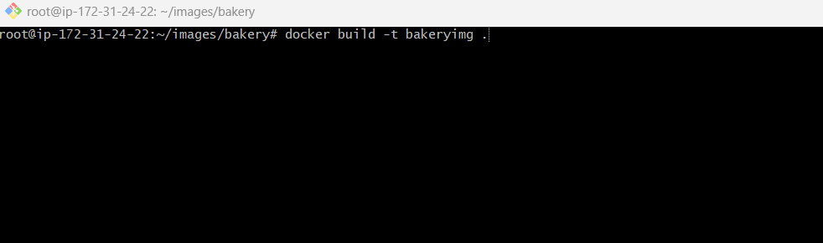


- Running the docker image
docker run -d --name bakerywebsite -p 9080:80 bakeryimg:latest

